Exp no:11 Determination and plotting of Magnetic Flux density in Ferromagnetic Materials with
different (i) length, (ii) width and (iii) magnetic field intensity.
Aim:
To write program for Magnetic flux density in ferromagnetic materials using SCILAB.

Software required:
•SCILAB version 6.0.1
PROGRAM :
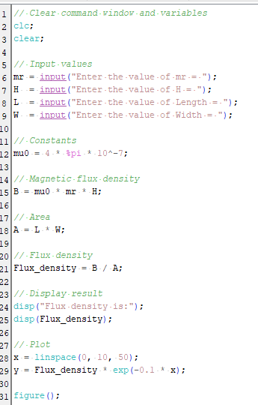
OUTPUT :
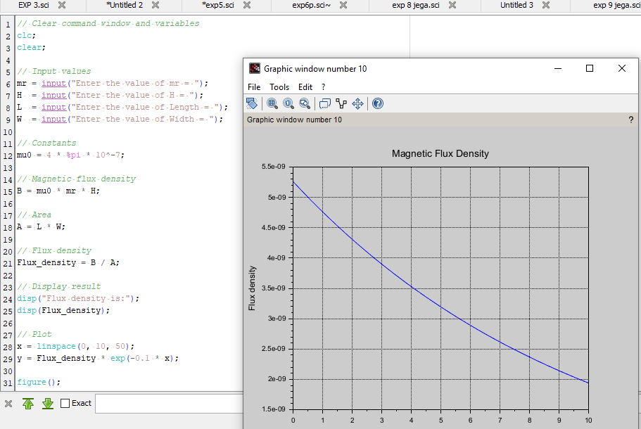
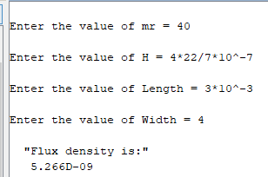

CALCULATIONS:
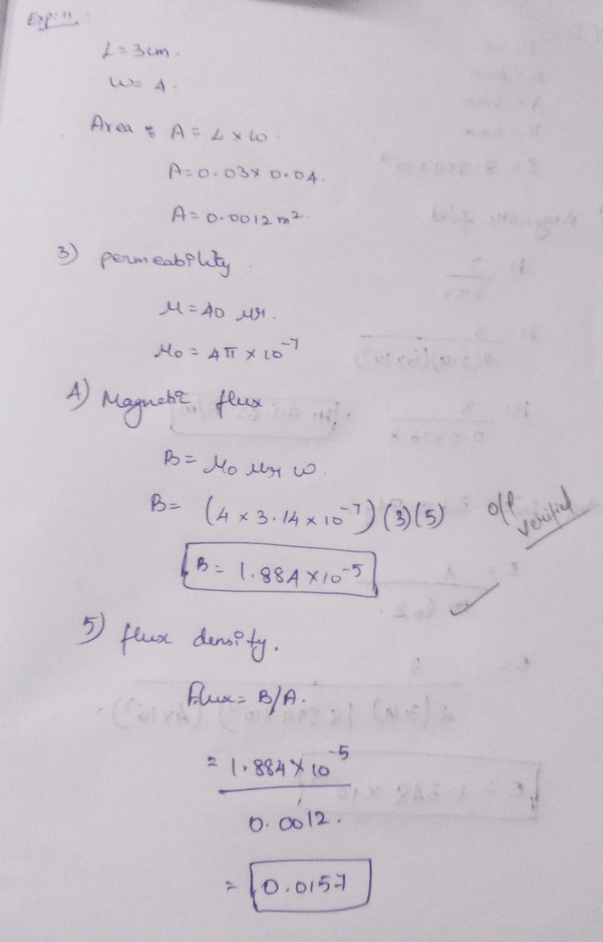

Case 1: Examine the effect of length of a ferromagnetic material on the magnetic flux density (B).
Analytical :
Calculate the magnetic flux density for the following conditions
The material is ferromagnetic with relative permeability (μr​) of 500.
The magnetic field intensity (H) is held constant at 100 A/m.
The length of the material varies from 0.1 m to 2 m.
Solution:
Magnetic Flux Density in a Ferromagnetic Material:
B=μ0μrH
Substituting the given values:
B=(4π×10−7 T)×500×(100 A/m)
B=6.28×10−2 T=0.0628 T
So, for any length of the material between 0.1 m to 2 m, the magnetic flux density B will remain constant at
0.0628 T.
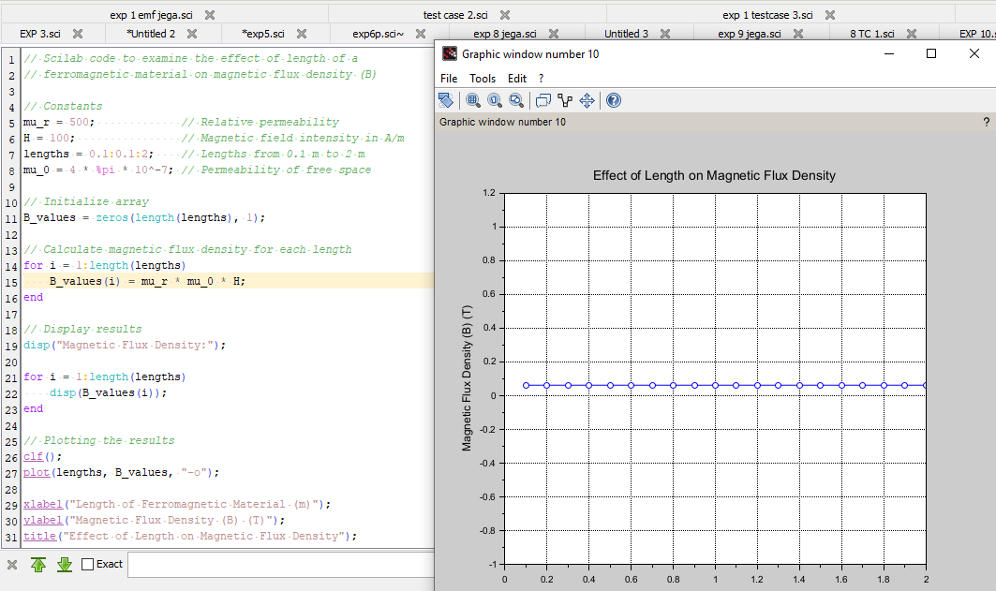
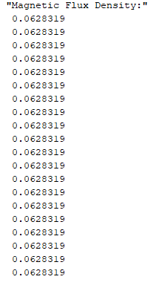
Case 2: To investigate how the magnetic flux density (B) in a ferromagnetic material changes with
different widths at a constant length and magnetic field intensity.
Analytical:
Calculate magnetic flux density (B) in a ferromagnetic material changes with different widths at a constant length
and magnetic field intensity for the following condtions
Material: Soft iron (same as in Case Study 1)
Length (L): Constant at 10 cm
Magnetic Field Intensity (H): Constant at 1000 A/m
Width (W): Varies from 2 cm to 10 cm (i.e., 2 cm, 4 cm, 6 cm, 8 cm, 10 cm)
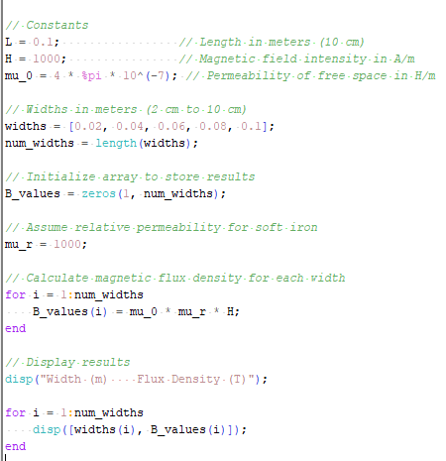
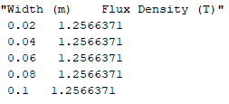
Case 3: To examine how the magnetic flux density (B) in a ferromagnetic material change with different
values of magnetic field intensity at constant length and width.
Analytical:
Calculate the magnetic flux density (B) in a ferromagnetic material change with different values of
magnetic field intensity at constant length and width.
Material: Soft iron (same as in the previous studies)
Length (L): Constant at 10 cm
Width (W): Constant at 5 cm
Magnetic Field Intensity (H): Varies from 200 A/m to 2000 A/m (i.e., 200 A/m, 500 A/m, 1000
A/m, 1500 A/m, 2000 A/m)

PROGRAM :

OUTPUT : 